Exclusive Offer for contributing members of the VIC Staff Associations/Unions
- You would like to improve your German with the special developed Weltakademie concept?
- Individual prioritisation, adjusted to the needs and interests
- PRICE: for 4 weeks (16 units)
- DUO COURSE: EUR 360, --
(instead of 450,-- per person)
- TRIO COURSE: EUR 280, --
(instead of 350,-- per person)
- Quattro COURSE: EUR 200, --
(instead of 250,-- per person)

German Courses

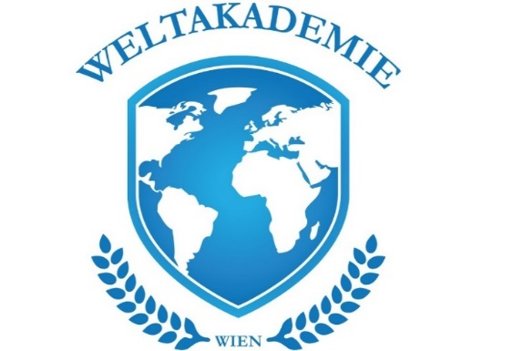
Why “Language school
Weltakademie”?
- free consultation
- no enrollment fee
- 1 free trial lesson
- WE OFFER ALL LANGUAGES
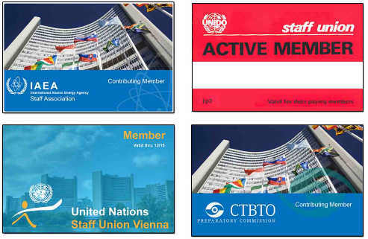
- all teachers are Native Speakers with academically training and teaching experience
- teachers with pedagogical Background
- all materials are included in the price
- class time from Monday to Saturday
- from 8 a.m. to 8 p.m.
- perfect cost effectiveness with success guarantee
More Weltakademie courses for KIDS and TEENS (-20% for VIC Staff):
- Individual German lessons: 10 units 360 € (instead of 490 € per person)
- Semester courses in small groups and all languages

