Special Offer -10%

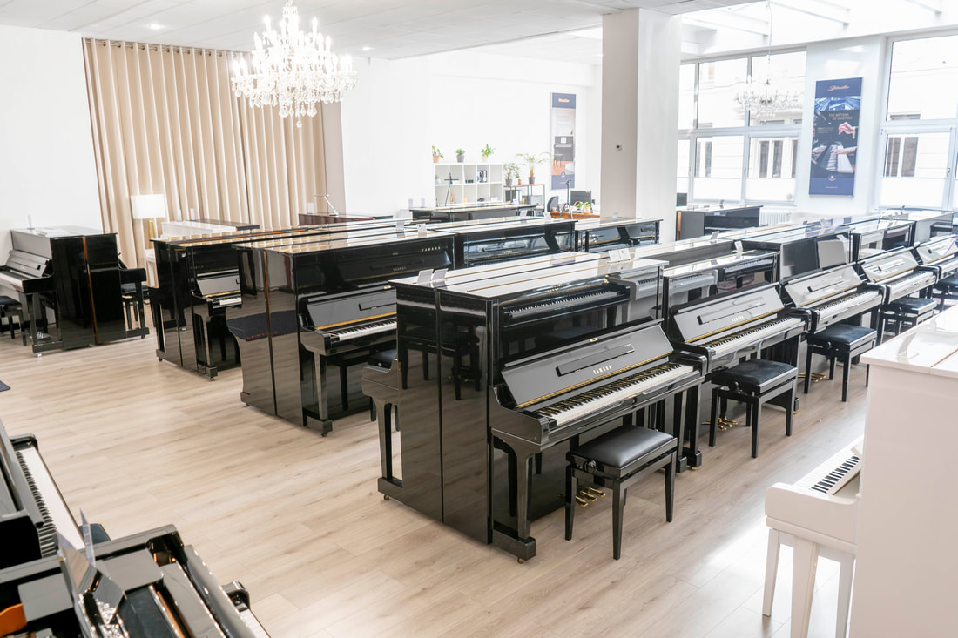
The showroom on 700m² with a selection of 100 pianos in tested quality.
Your partner for Kawai, Blüthner, Petrof, Ritmüller as well as refurbished and used Yamaha & Kawai in Vienna.

T: +43 660 759 8264
E: hallo@klavierloft.at
W: www.KlavierLoft.at

