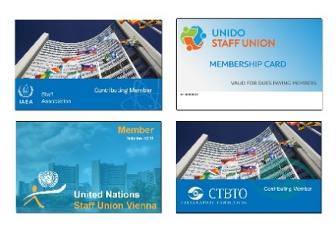
Exclusive offer for contributing members of the VIC STAFF Associations / Unions

We offer you to deliver food for lunch/dinner at the U.N Office at a discounted rate of -10% on the order (minimum spend 100 Euros).
We would also like to extend this 10% offer for contributing members of the VIC STAFF Associations / Unions to get food delivered at home (in respect to the districts to which we deliver (1,2,3,4,6,7,8,9,16,17,18,19,20) from In-Dish at a Minimum Spend of 50 Euros.
reservations@in-dish.at
+43 1 94 12 801
Schwarzenbergstrasse 8
1010 Wien
Österreich

