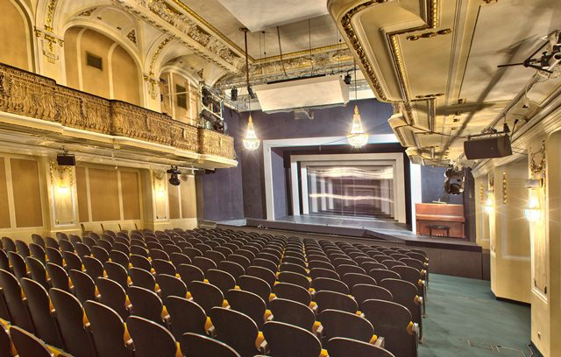
Exclusive offer for contributing members of the
VIC STAFF Associations / Unions

Kammeroper © Werner Kmetitsch

-10% discount all-season
at the KAMMEROPER
Discount information:
- 10% discount all-season for all own productions (opera/concert) at the Kammeroper
(> guest performances excluded)

Booking conditions:
- Keyword: “VIC STAFF ASSOCIATIONS AND UNIONS”
- Phone: +43 (0)1 58830-2903 > Mon - Fri 9 a.m. - 6 p.m. (credit card data required)
- Mail: info@theater-wien.at (credit card data required)
- Deposit of tickets at the night box-office at the Kammeroper (Fleischmarkt 24, 1010 Vienna)

Kammeroper
Fleischmarkt 24
1010 Vienna
www.kammeroper.at

