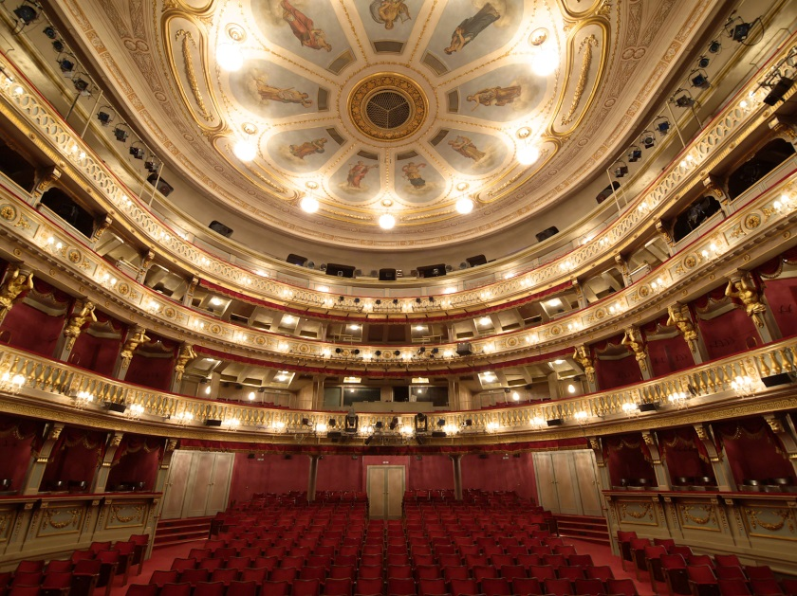
Exclusive offer for contributing members of the
VIC STAFF Associations / Unions

Theater an der Wien © Paul Ott
-10% discount all-season
at the THEATER AN DER WIEN
Discount information:
- 10% discount all-season for all own productions (opera/concert/ballet) at the Theater an der Wien (> guest performances excluded)

Booking conditions:
- Keyword: “VIC STAFF ASSOCIATIONS AND UNIONS”
- Phone: +43 (0)1 58830-2903 > Mon - Fri 9 a.m. - 6 p.m. (credit card data required)
- Mail: info@theater-wien.at (credit card data required)
- Deposit of tickets at the night box-office at the Theater an der Wien (Linke Wienzeile 6,
1060 Vienna)

Theater an der Wien
Linke Wienzeile 6
1060 Vienna
www.theater-wien.at

